29/MR/2022

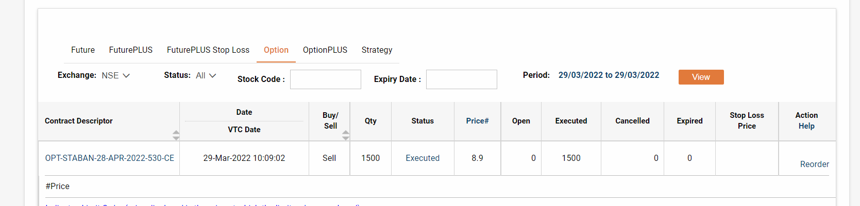

29/MARCH/2022

